Test Execution Log and Screenshots

Test Id_Name | GGP-Web-001_Login Page Validation
Workflow | Default
Shared DataSet | GetgoURL
Test DataSet | GetGoPayData
Execution Date & Time
Test Status | Passed

Step Name: Script GGP-Web-001 Runinng on browser (CHROME)
Step Description: Launch the GetGo application url in the browser
Expected Result: GetGo application should be launched sucessfully in the browser
Actual Result: Application 'https://getgopay-uat.unionbankph.com/login/email' is launched.
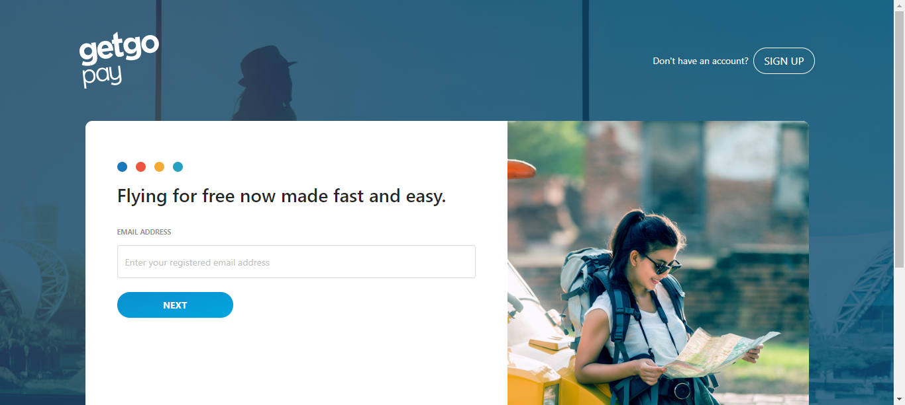

Step Name: Script GGP-Web-001 Runinng on browser (CHROME)
Step Description: Check if SignUp button is displayed at the Right top corner of GetGo Login Page
Expected Result: SignUp button should be displayed at the Right top corner of GetGo Login Page
Actual Result: The field 'btnSignup' is present in the screen 'Getgo -> Loginpage'.

Step Name: Script GGP-Web-001 Runinng on browser (CHROME)
Step Description: Check if Email address text box is displayed in the GetGo Login Page
Expected Result: Email address text box should be displayed in the GetGo Login Page
Actual Result: The field 'editEmailAddress' is present in the screen 'Getgo -> Loginpage'.

Step Name: Script GGP-Web-001 Runinng on browser (CHROME)
Step Description: Check if Next button is displayed in the GetGo Login Page
Expected Result: Check if Next button should be displayed in the GetGo Login Page
Actual Result: The field 'NextBtn' is present in the screen 'Getgo -> Loginpage'.

Step Name: Script GGP-Web-001 Runinng on browser (CHROME)
Step Description: Check if Don't have an account? Is displayed in the GetGo Login Page
Expected Result: Don't have an account? Should be displayed in the GetGo Login Page
Actual Result: Expected Value 'Don't have an account?' matches with the value in the application.

Step Name: Script GGP-Web-001 Runinng on browser (CHROME)
Step Description: Check if GetGo pay logo is displayed in the GetGo Login page
Expected Result: GetGo pay logo should be displayed in the GetGo Login page
Actual Result: The field 'IMGGetGoPayLogo' is present in the screen 'Getgo -> Loginpage'.

Step Name: Script GGP-Web-001 Runinng on browser (CHROME)
Step Description: Check if blue circle image is displayed in the GetGo Login page
Expected Result: Blue circle image should be displayed in the GetGo Login page
Actual Result: The field 'IMGBlueCircle' is present in the screen 'Getgo -> Loginpage'.

Step Name: Script GGP-Web-001 Runinng on browser (CHROME)
Step Description: Check if red circle image is displayed in the GetGo Login page
Expected Result: Red circle image should be displayed in the GetGo Login page
Actual Result: The field 'IMGRedCircle' is present in the screen 'Getgo -> Loginpage'.

Step Name: Script GGP-Web-001 Runinng on browser (CHROME)
Step Description: Check if yellow circle image is displayed in the GetGo Login page
Expected Result: Yellow circle image should be displayed in the GetGo Login page
Actual Result: The field 'IMGYellowCircle' is present in the screen 'Getgo -> Loginpage'.

Step Name: Script GGP-Web-001 Runinng on browser (CHROME)
Step Description: Check if cyan circle image is displayed in the GetGo Login page
Expected Result: Cyan circle image should be displayed in the GetGo Login page
Actual Result: The field 'IMGCyanCircle' is present in the screen 'Getgo -> Loginpage'.

Step Name: Script GGP-Web-001 Runinng on browser (CHROME)
Step Description: Check if GetGo pay quotes is displayed in the GetGo pay Login page
Expected Result: GetGo pay quotes should be displayed in the GetGo pay Login page
Actual Result: Expected Value 'Flying for free now made fast and easy.' matches with the value in the application.

Step Name: Script GGP-Web-001 Runinng on browser (CHROME)
Step Description: Check if Email address verbiage is displayed in the GetGo Login Page
Expected Result: Email address verbiage should be displayed in the GetGo Login Page
Actual Result: Expected Value 'EMAIL ADDRESS' matches with the value in the application.

Step Name: Script GGP-Web-001 Runinng on browser (CHROME)
Step Description: Check if Email address text box verbiage is displayed in the GetGo Login Page
Expected Result: Email address text box verbiage should be displayed in the GetGo Login Page
Actual Result: Expected Value of the 'Enter your registered email address' attribute of the field 'editEmailAddress' in the screen 'Getgo -> Loginpage' matches with the value in the application.

Step Name: Script GGP-Web-001 Runinng on browser (CHROME)
Step Description: Check if Footer label ABOUT GETGO • FAQ • TERMS AND CONDITIONS • PRIVACY POLICY • CONTACT US is displayed in the GetGo Login page
Expected Result: Footer label ABOUT GETGO • FAQ • TERMS AND CONDITIONS • PRIVACY POLICY • CONTACT US should be displayed in the GetGo Login page
Actual Result: The field 'loginfooterlabel1' is present in the screen 'Getgo -> Loginpage'.

Step Name: Script GGP-Web-001 Runinng on browser (CHROME)
Step Description: Check if Footer label Copyright 2017 i2cinc. All rights reserved.
For the best experience, please use the latest browser version. is displayed in the GetGo Login page
Expected Result: Check if Footer label Copyright 2017 i2cinc. All rights reserved.
For the best experience, please use the latest browser version. Should be displayed in the GetGo Login page
Actual Result: The field 'loginfooterlabel2' is present in the screen 'Getgo -> Loginpage'.

Step Name: Script GGP-Web-001 Runinng on browser (CHROME)
Step Description: Enter valid emailid
Expected Result: email id should be entered
Actual Result: Value '(003)Gopinath.rajaram@unionbankph.com' is entered in the field 'editEmailAddress' of the screen 'Getgo -> Loginpage'.

Step Name: Script GGP-Web-001 Runinng on browser (CHROME)
Step Description: click Next button
Expected Result: Next button should be displayed and navigate to a page with provision to enter password
Actual Result: Button 'NextBtn' in the screen 'Getgo -> Loginpage' is clicked.
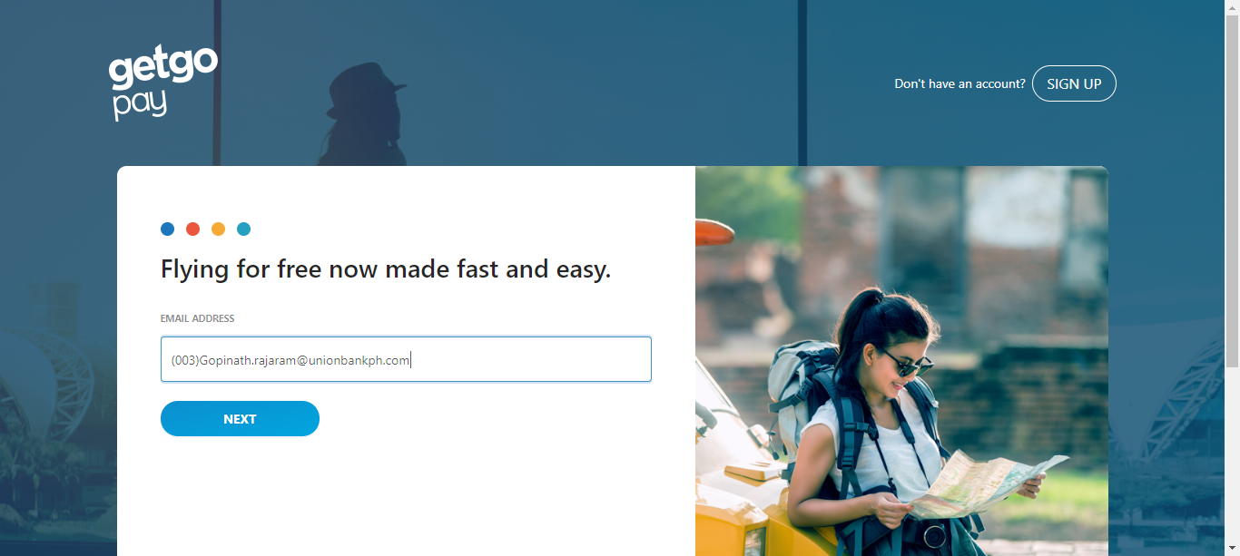

Step Name: Script GGP-Web-001 Runinng on browser (CHROME)
Step Description: Wait for few seconds
Expected Result: Wait should be successful
Actual Result: Application has waited for 'WAIT || 1' Seconds.
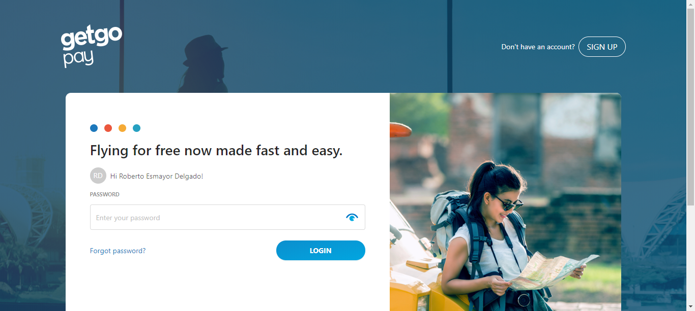

Step Name: Script GGP-Web-001 Runinng on browser (CHROME)
Step Description: Check if SignUp button is displayed at the Right top corner of GetGo Login Page
Expected Result: SignUp button should be displayed at the Right top corner of GetGo Login Page
Actual Result: The field 'btnSignup' is present in the screen 'Getgo -> Loginpage'.

Step Name: Script GGP-Web-001 Runinng on browser (CHROME)
Step Description: Check if greeting message is displayed
Expected Result: Greeting message should be displayed
Actual Result: The field 'usergreetingmessage' is present in the screen 'Getgo -> Loginpage'.

Step Name: Script GGP-Web-001 Runinng on browser (CHROME)
Step Description: Check if password text box is displayed in the GetGo Login Page
Expected Result: password text box should be displayed in the GetGo Login Page
Actual Result: The field 'editpwd' is present in the screen 'Getgo -> Loginpage'.

Step Name: Script GGP-Web-001 Runinng on browser (CHROME)
Step Description: Check if Login button is displayed in the GetGo Login Page
Expected Result: Check if Login button should be displayed in the GetGo Login Page
Actual Result: The field 'LoginBtn' is present in the screen 'Getgo -> Loginpage'.

Step Name: Script GGP-Web-001 Runinng on browser (CHROME)
Step Description: Check if Don't have an account? Is displayed in the GetGo Login Page
Expected Result: Don't have an account? Should be displayed in the GetGo Login Page
Actual Result: Expected Value 'Don't have an account?' matches with the value in the application.

Step Name: Script GGP-Web-001 Runinng on browser (CHROME)
Step Description: Check if GetGo pay logo is displayed in the GetGo Login page
Expected Result: GetGo pay logo should be displayed in the GetGo Login page
Actual Result: The field 'IMGGetGoPayLogo' is present in the screen 'Getgo -> Loginpage'.

Step Name: Script GGP-Web-001 Runinng on browser (CHROME)
Step Description: Check if blue circle image is displayed in the GetGo Login page
Expected Result: Blue circle image should be displayed in the GetGo Login page
Actual Result: The field 'IMGBlueCircle' is present in the screen 'Getgo -> Loginpage'.

Step Name: Script GGP-Web-001 Runinng on browser (CHROME)
Step Description: Check if red circle image is displayed in the GetGo Login page
Expected Result: Red circle image should be displayed in the GetGo Login page
Actual Result: The field 'IMGRedCircle' is present in the screen 'Getgo -> Loginpage'.

Step Name: Script GGP-Web-001 Runinng on browser (CHROME)
Step Description: Check if yellow circle image is displayed in the GetGo Login page
Expected Result: Yellow circle image should be displayed in the GetGo Login page
Actual Result: The field 'IMGYellowCircle' is present in the screen 'Getgo -> Loginpage'.

Step Name: Script GGP-Web-001 Runinng on browser (CHROME)
Step Description: Check if cyan circle image is displayed in the GetGo Login page
Expected Result: Cyan circle image should be displayed in the GetGo Login page
Actual Result: The field 'IMGCyanCircle' is present in the screen 'Getgo -> Loginpage'.

Step Name: Script GGP-Web-001 Runinng on browser (CHROME)
Step Description: Check if GetGo pay quotes is displayed in the GetGo pay Login page
Expected Result: GetGo pay quotes should be displayed in the GetGo pay Login page
Actual Result: Expected Value 'Flying for free now made fast and easy.' matches with the value in the application.

Step Name: Script GGP-Web-001 Runinng on browser (CHROME)
Step Description: Check if PASSWORD verbiage is displayed in the GetGo Login Page
Expected Result: PASSWORD verbiage should be displayed in the GetGo Login Page
Actual Result: Expected Value 'PASSWORD' matches with the value in the application.

Step Name: Script GGP-Web-001 Runinng on browser (CHROME)
Step Description: Check if PASSWORD text box verbiage is displayed in the GetGo Login Page
Expected Result: PASSWORD text box verbiage should be displayed in the GetGo Login Page
Actual Result: Expected Value of the 'Enter your password' attribute of the field 'editpwd' in the screen 'Getgo -> Loginpage' matches with the value in the application.

Step Name: Script GGP-Web-001 Runinng on browser (CHROME)
Step Description: Check if Footer label ABOUT GETGO • FAQ • TERMS AND CONDITIONS • PRIVACY POLICY • CONTACT US is displayed in the GetGo Login page
Expected Result: Footer label ABOUT GETGO • FAQ • TERMS AND CONDITIONS • PRIVACY POLICY • CONTACT US should be displayed in the GetGo Login page
Actual Result: The field 'loginfooterlabel1' is present in the screen 'Getgo -> Loginpage'.

Step Name: Script GGP-Web-001 Runinng on browser (CHROME)
Step Description: Check if Footer labelCopyright 2018 UnionBank of the Philippines. All rights reserved. is displayed in the GetGo Login page
Expected Result: Footer label CCopyright 2018 UnionBank of the Philippines. All rights reserved. Should be displayed in the GetGo Login page
Actual Result: The field 'loginfooterlabel2' is present in the screen 'Getgo -> Loginpage'.

